**MongoDB Database - the Product Order database.**

The Product Order database maintains an inventory of TV products of various brands and models. It allows users to place orders for one or more of these items, and offers discounts on these purchases. In the Product Order database, there are mainly four categories of information:

● Product information

● Inventory information

● User information

● Order information

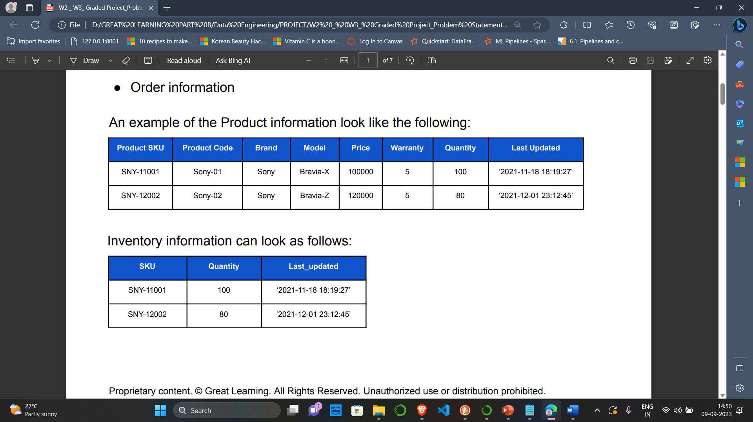

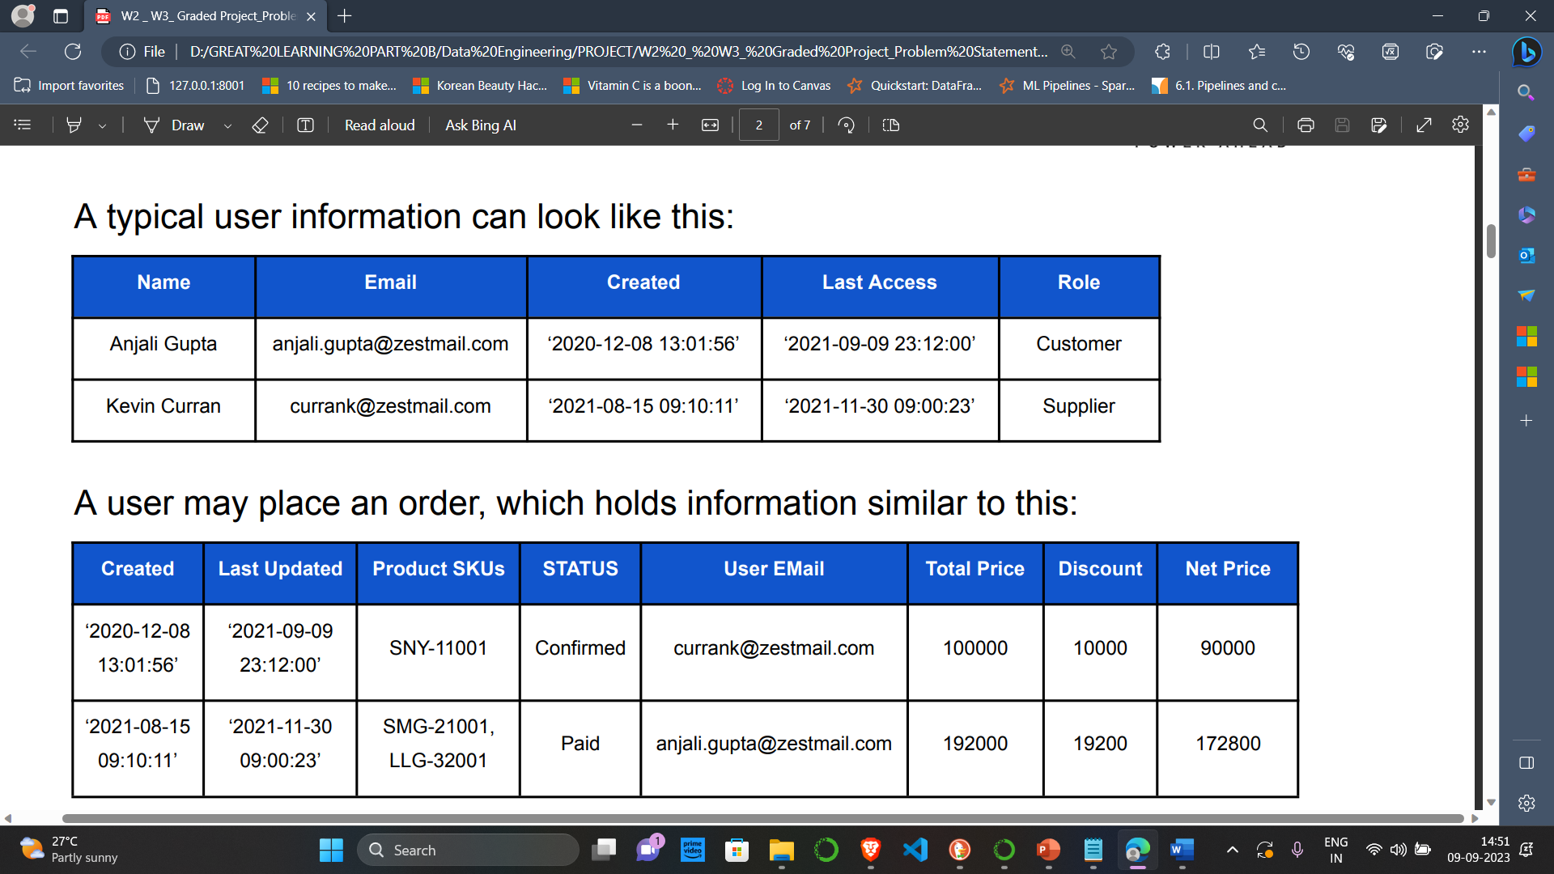

**Objective:**

Having all this information in place we need to create a Database called ProductOrder and various collections in it. The collections needed and attributes which need to be in every collection are given by the Organization. All you have to do is create collections with data in it and write some queries so that the organization can retrieve required information.

**Files Provided:**

The resources that have been shared with you as part of the zipped JSON docs folder, there are 4 main files.

* Product_info.json,
* Inventory_info.json,
* User_info.json and
* Order_info.json

The JSON files that contain the information to be inserted into the database.